44th ANNUAL BIFD CONFERENCE
23rd – 25th October 2026
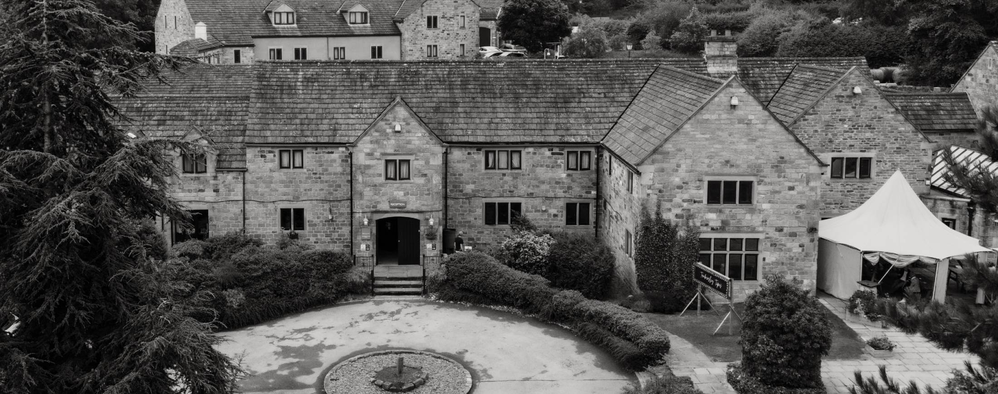

Mercure Tankersley Manor Hotel
Church Ln, Tankersley, Barnsley S75 3DQ

The BIFD Invites You To Conference 2026……

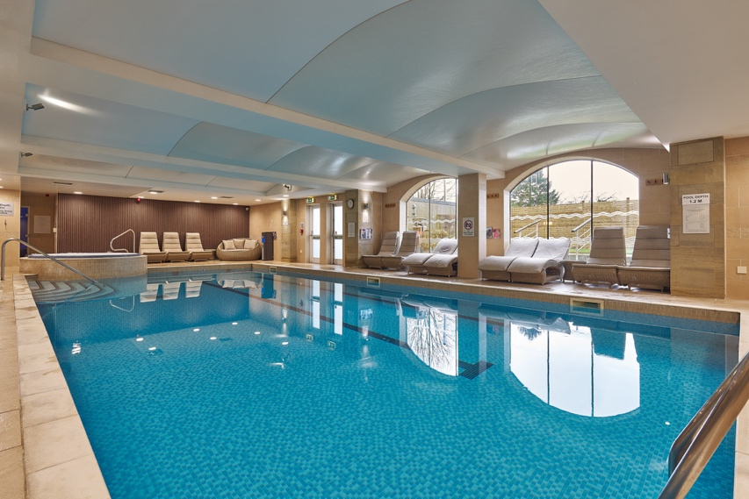
BIFD National President, Clive Pearson, and his wife Leanne cordially invite all Members, Fellows, Students, Associates, Presidents of Kindred Associations, and Distinguished Guests to attend the upcoming Conference and Gala Dinner of The British Institute of Funeral Directors. The event will take place from 23rd to 25th October 2025 at The Mercure Tankersley Manor Hotel.
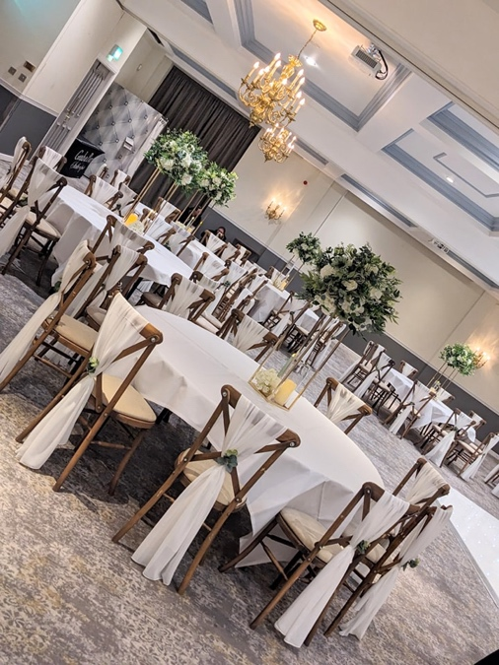
Tankersley Manor centres around a renovated 17th-century residence, conveniently located just a minute from Junction 36 off the M1 and offering free parking. Its 98 refurbished rooms are designed with elegant craftsmanship and bursts of colour to create an inviting atmosphere for guests. You’ll find leisure amenities such as a gym, swimming pool, jacuzzi, sauna, steam room, and five spa treatment rooms—perfect for enjoying some relaxation during Conference Weekend (advance booking is recommended). The Woodman Restaurant offers a cozy spot by the fire where you can unwind and savour classic Yorkshire dishes.

Nearby attractions include Elsecar Heritage Centre, Cannon Hall, and Chatsworth House.
The President’s Charity For 2026……



Clive and Leanne have selected The Samaritans as the Institute Charity for 2026.

Founded in 1953 by Chad Vara, who recognised through his own life experiences the importance of listening, the organisation empowers individuals by offering a compassionate ear to callers wishing to talk about their emotions, feelings, challenges, and concerns, hoping to help them make positive informed decisions about their lives.

The Samaritans' mission is dedicated to reducing the number of individuals contemplating or attempting to take their own lives. The organisation currently provides comprehensive 24/7 telephone support across England, Wales, Scotland, and Ireland. Its services have expanded to help individuals facing a broad range of issues, including suicide, depression, anxiety, stress, loneliness, all forms of abuse, and alcohol or drug use.

The itinerary so far…

Friday 23rd October 2026

The Education Committee is scheduled to convene in the morning, followed by a meeting of the Board of Directors in the afternoon.

Once you've settled into your rooms, Clive welcomes you to join him and Leanne for a three-course dinner in the hotel's function suite.

Saturday 24th October 2026

The Annual General Meeting will be held in the morning, and a buffet lunch will follow afterward.

In the afternoon, Clive has tentative plans for an activity of interest; further details will be provided once arrangements are confirmed.

The evening will commence with a drink’s reception, followed by a three-course dinner accompanied by wine, cheese and biscuits, as well as tea and coffee. The programme will include the Diploma Awards Ceremony and the official Handover of Offices, concluding with music and dancing later in the evening.

Earlier than 23rd or later than 25th October 2026

Should you wish to extend your stay, we have arranged favourable rates for dates surrounding the Conference, allowing you to enjoy Yorkshire for a longer visit. Kindly inform us of your specific requirements, and we will endeavour to secure the most advantageous arrangements on your behalf.

